**Kishan Sarpangala**

**M04307966**

**Assignment 3**

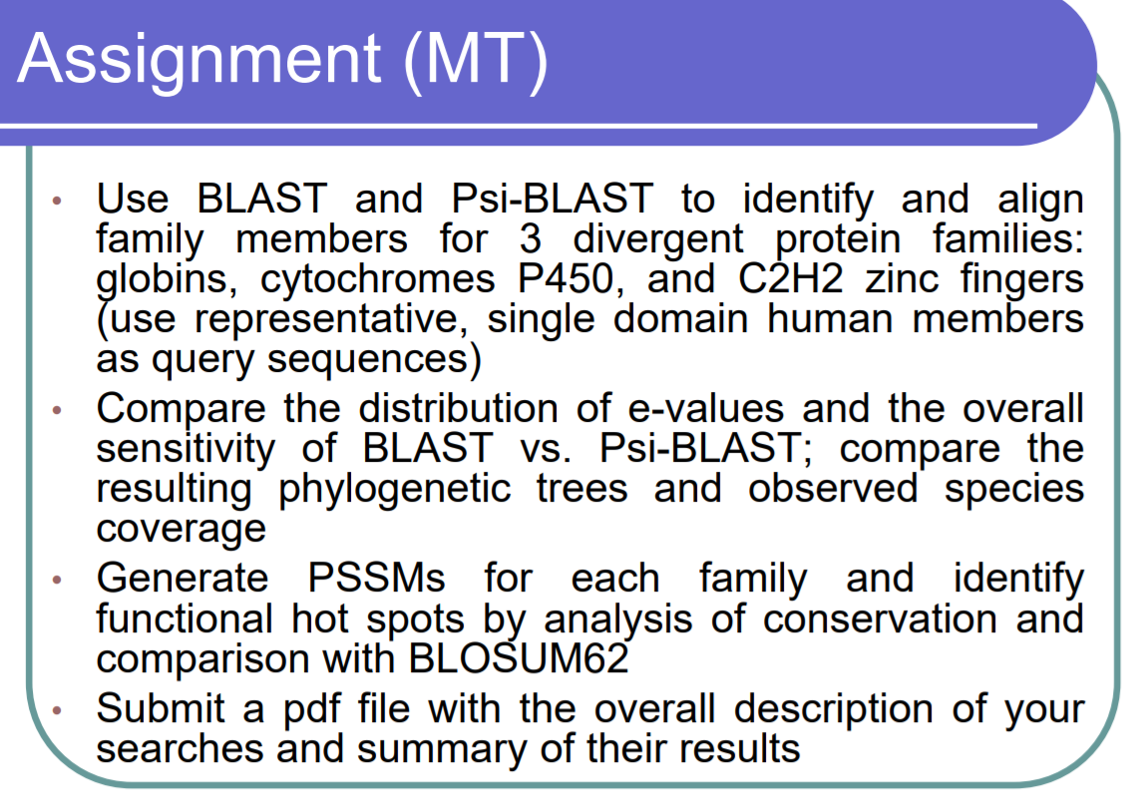

**BLAST RESULTS**

**Neuroglobin**

Alignment Result: Diagram Tree of Neuroglobin Initial Neuroglobin Fasta file

  

Cytochromes P450

Alignment Result :



C2H2 Zinc Fingers